**Web Programming - Project requirements**

**The final project will have:**

* at least 4 pages with menu, header, content, footer
* registration page
* login page
* CRUD database operations

**Deadlines:**

* lab 2 - weeks 3 and 4 - each student has filled in the form with the topic and defined the HTML structure of the pages
* lab 6 - weeks 11 and 12 - project presentation.

**Important:** no frameworks! :)

**References:**

* <https://www.w3schools.com/default.asp>
* <http://www.w3schools.com/tags/>

#### **Section HTML**

Your HTML page should contain:

1. All basic HTML5 elements: <!DOCTYPE>, <html>, <head>, <title>, <body>,<h1>...,<p>, <br>, <hr>, <!--...-->
2. Some text formatting elements such as <b>, <code>, <s>, <u>
3. Various <forms> elements and <input> elements
4. Tables with colspan and rowspan attributes
5. Nested tables
6. Nested lists
7. Images as hyperlinks
8. Multiple semantics elements such as <main>, <article>, <section>, <header>, <footer>, etc.

The HTML code must be validated at <http://validator.w3.org/> with no errors and warnings.

#### **2. Section CSS**

1. Use one external .css file for the entire project
2. Use CSS 2D transform properties (ex: scale() the logo image)
3. Use gradient background for <header>
4. Use a <footer> at the last element of end of all pages
5. The style of a menu item will change on mouseover.
6. Use a style for every <form> element and <input> element

#### **3. Section JS**

1. Validate form fields (email format, date format, etc.) and display next to them a sign showing if the input is valid or not.
2. One form must contain dynamically build drop-downs (ex: county + city, the city list will update on county change).
3. One HTML page must contain at least one list (<ol> or <ul>) that shows only the first 2 elements, for the rest of them use a “View more” button.

**4. Section JQuery**

1. Implement a live search for a <select> input:

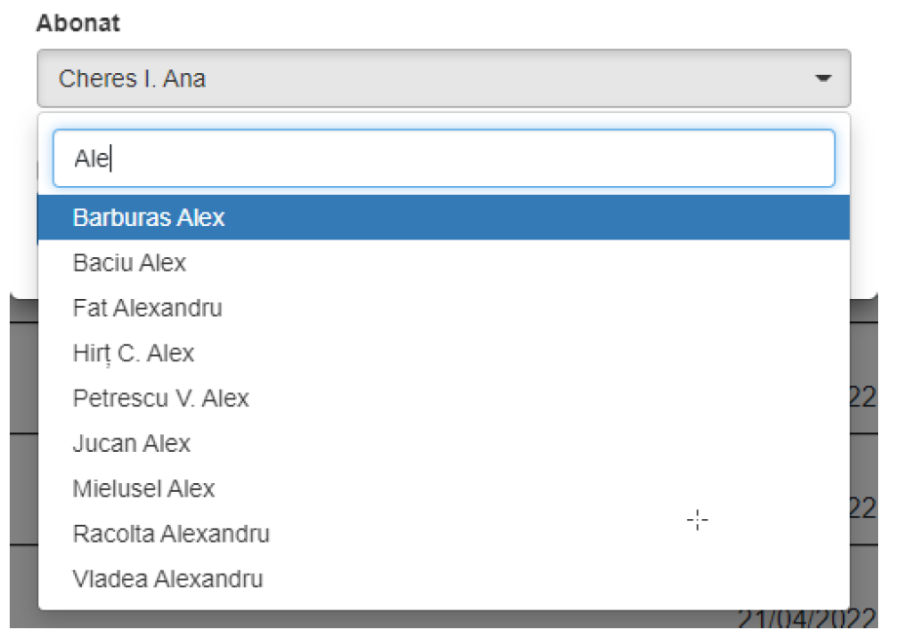

1. Implement a search by keywords and sorting by columns for at least one table
2. Display a pop-up when the user selects one image by clicking on it, like the example below:



**5. Section PHP**

1. All information about the products must be stored and extracted from the database using CRUD operations.
2. The application must have at least 2 user roles (admin, registered user).
3. The application must be deployed on a web server.